**SCHOLARSHIP BIOLOGY**

**Question 1 THE ABCC11 GENE**

Wax in the external canal of the human ear may be wet or dry.

Whether earwax is wet or dry has been traced to a gene called ABCC11, found on chromosome 16 in humans. The ABCC11 gene codes for a protein involved with the transport of secretory products across cell membranes. Which products are secreted determines the type of earwax present in humans. Earwax is wet unless an individual has Adenine (A) at a particular site instead of Guanine (G), in which case the wax becomes the dry form. People who inherit the version of the gene that has A from both parents have dry earwax. People who inherit two of the G versions, or one G and one A, have wet earwax.

Dry earwax is very common in East Asians, for example in China 100% of the population has dry earwax. However, it is very rare in both Europe and Africa (less than 3% of the population). Dry earwax is intermediate in frequency in the populations of Central Asia, for example in India 54% of the population has dry earwax. In Japan, 69% of the population has dry earwax. In North America, 30% of native Americans have dry earwax, while it is present in no more than 1% of Americans of European or African descent.

**Estimated percentage of population with dry earwax**

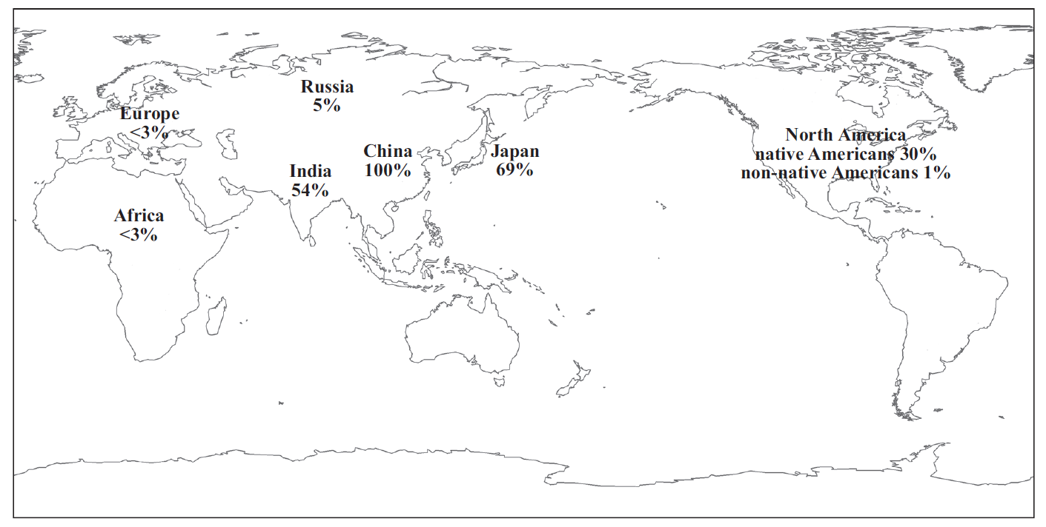

[www.clarkeresearch.org/resources/World_Map.jpg](http://www.clarkeresearch.org/resources/World_Map.jpg)

Use biological knowledge, together with information from the above resource material, to discuss:

• the origins and inheritance patterns of dry earwax

• the evolutionary factors that may have resulted in the present-day distribution of both types of earwax.

2

**Question 2 COLONY COLLAPSE DISORDER IN HONEY BEES**

Honey bees (*Apis mellifera*) are social insects and live in colonies in hives. Honey bees were introduced from Europe to the USA to pollinate crop plants; all honey bees in the USA today are from only four genetic lines. While native bee pollinators exist, honey bees are the main pollinators of commercial crops throughout the world.

American beekeepers commonly truck their hives long distances across the country two to three times a year to pollinate the crops as they come into flower. Typical crops dependent on honey bee pollination include:

• nut crops, such as almonds

• fruit crops, such as apples, pears, peaches, cherries

• berry crops, such as blueberries, strawberries

• vegetables, such as cucumbers, onions, carrots, asparagus, broccoli, cauliflowers.

Most bee colonies are used to pollinate only one type of crop, eg apples. During the winter, the lack of flowers to provide nectar means that beekeepers in America provide the colonies with substitute food, such as high fructose corn syrup (HFCS).

Insecticides are applied to crops to kill insect pests. Recently developed insecticides include the neonicotinoids, which are neurotoxins that attack the nervous system. Neonicotinoids are applied to soil or seeds and are absorbed by plant tissues, including pollen and nectar, as the plant grows and develops. Bees use nectar to make honey, which is stored in the hive and used as food by the mature bees. Immature bees are not fed honey. Scientists have identified over 100 different insecticides in pollen, bees, and beeswax.

Bee colonies are attacked by a variety of pathogens and parasites.

One major pathogen is the acute bee paralysis virus (IAPV), which causes a breakdown of the ribosomes in infected bees. The infected bees become paralysed and die when outside the hive.

Two major parasites are:

• the varroa mite (*Varroa destructor)*, which feeds on the blood of bees, wounding the bee and weakening its immune system. Varroa mites are also vectors for viruses such as IAPV.

• the fungus (*Nosema ceramae)*, which infects the intestinal tract of bees, reducing the bee’s ability to process food, and makes the bee susceptible to infection and chemical attack.

During the colder winter months in the USA, on average about 15 – 25% of bee colonies die. However, in late 2006 American beekeepers began reporting much higher losses of colonies (up to 90% in extreme cases), and in the four years since then, more than a third of bee colonies (approximately three million) have failed to survive the winter in the USA. Similar losses have been reported in Canada and Europe, resulting in the loss of billions of honey bees.

This phenomenon has been termed Colony Collapse Disorder (CCD) and to date no cause has been identified. The main symptoms of CCD are a bee hive that has a live queen in residence with very few or no adult bees; no dead bees are present in the hive. Honey is often present in the hive along with immature bees. As there are no workers to care for these young bees, the colony soon dies.

Scientists are investigating the possible causes of CCD; it is unlikely that it is caused by a single factor.

Discuss the likely role and interaction of named factors in the cause and spread of CCD.

Analyse the likely ecological impact of CCD on managed and natural ecosystems.

**Question 3 AMAZONIAN BUTTERFLIES**

The Amazon rainforest in South America is a biodiverse ecosystem. There are large numbers of plant and animal species making up the food web, including over 350 species of predatory insectivorous birds.

In one small area of the rainforest, about 15 km2, there are 60 different species of Ithomiine butterflies. These 60 species of butterflies have only eight different colour pattern phenotypes. Each of the different phenotypes is found within a particular habitat within this small area. Therefore the different phenotypes are rarely seen together. Scientists initially assumed that each of these phenotypes indicated that there were eight different species of butterflies. Genetic analysis has disproved this, and the resulting phylogeny is shown opposite. It shows, for example, that there are 11 species of butterfly with the ‘eurimedia’ phenotype.

Evidence shows that each species of butterfly lays its eggs on only one variety of plant, which is different to other species of butterfly with the same phenotype found in their habitat. The caterpillars feed exclusively on this host plant. However, adult butterflies drink nectar from a range of different flowers which may be in common with other butterflies of the same phenotype.

Butterflies sharing the same colour pattern display Mullerian and /or Batesian mimicry.

Discuss how

• ecological relationships

AND

• evolutionary processes and patternsmay have worked together to produce the large number of Ithomiine butterfly species, but only a small number of colour pattern phenotypes.

**Diagram showing the relationship between the species and the phenotype in these butterflies**



Source (adapted): www.plosbiology.org/article/info:doi/10.1371/journal.pbio.0060300